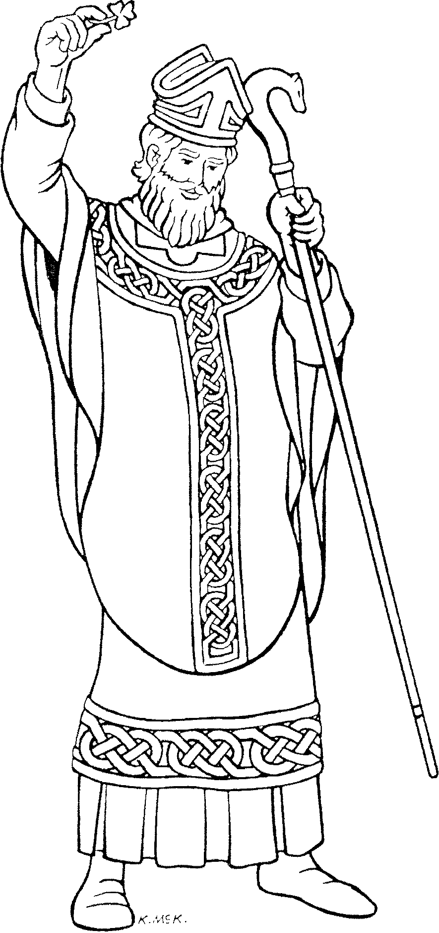
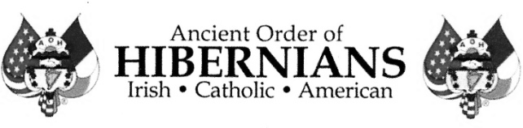
St. Patrick
Apostle of Ireland
c. AD 389-461
St. Patrick used the little green shamrock to teach that just as the three leaves form one plant, the Three Persons of the Holy Trinity are one God.

The Northern Virginia Ancient Order of Hibernians (AOH) invites all area 1st through 4th grade students to enter the St. Patrick Coloring Contest.

Three winners will be chosen from each grade. All winners will receive a T Shirt and an Award certificate containing the winning entry.
GRAND PRIZE: $50.
Entries must be completed with
WAX CRAYON ONLY!

This entry was created with NO HELP by:

Name_____________________________

Grade___

THANK YOU TO OUR SPONSOR




Learn more about St. Patrick https://mychal-judge-va-aoh.org/
Additional Information must be completed on back side of this entry

Contestant Information Required
All entries are centrally judged, using the face side of this entry only – we need this information so we can contact schools and programs about winners, invite them to the award presentation, and deliver the T-Shirts and Certificates.

School________________________ or RE Parish Program ___________________
Parish ________________________
Full name of Student_______________________________
T Shirt Size: Child Small. ___ Child Medium. __Child Large. ___Adult Small___

